**Setting up Multi-job in Jenkins**

**Follow the below steps to install Multijob plugin :**

1. Launch Jenkins in browser
2. Go to Manage **Jenkins** >> **Manage Plugins** >> **Available** and select the **Multijob Plugin** from the list of plugins and click Install without restart button

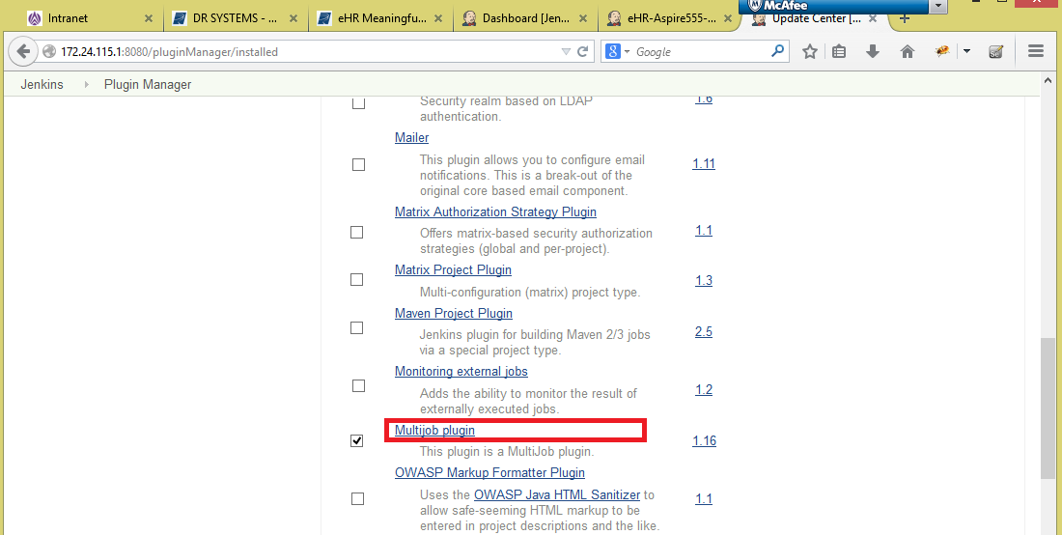

1. To confirm if the plugin has been installed successfully, go to **Manage Jenkins** >> **Manage Plugins** >> Installed, the list of plugins should include **Multijob plugin**.

**Follow the below steps to create a multijob :**

1. Go to Jenkins dashboard, click **New Item** and give the job and select **MultiJob Project** radio button and then click **Ok** button

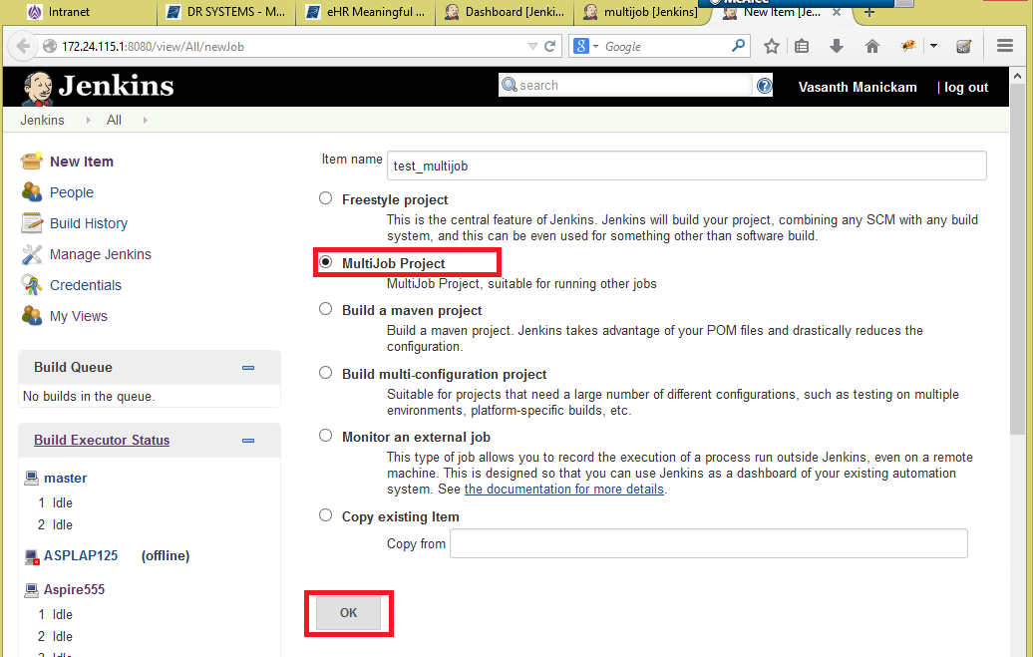

1. Now the configuration page will be displayed, here we give the execution environment details
   1. Set the execution environment (machine where the tests will be run)

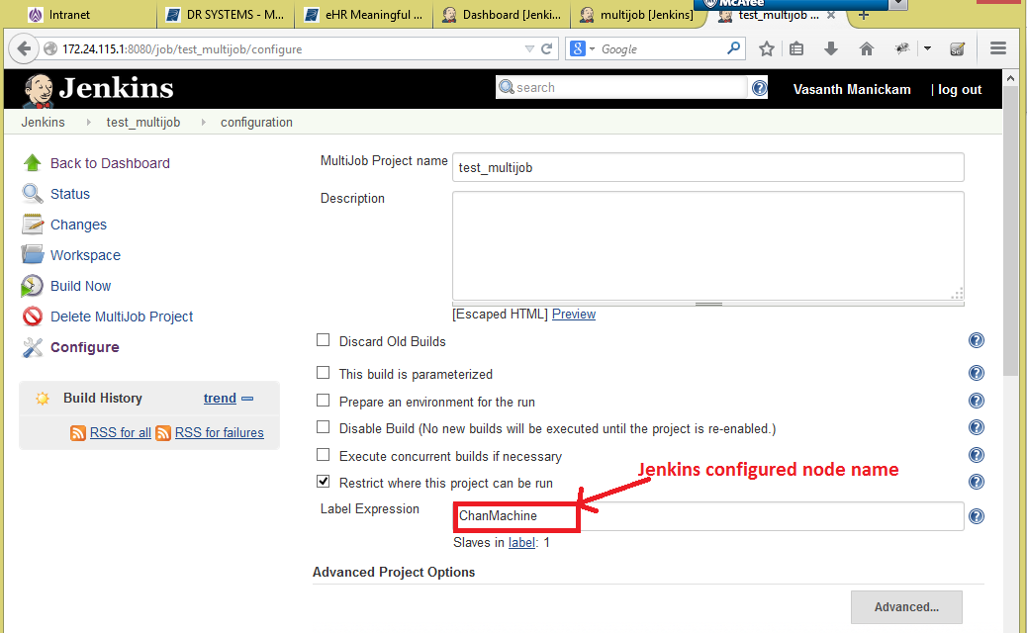

* 1. Select the repository tool (we use **Subversion**) radio button under **Source Code Management**. The source code for test script will be copied to this location

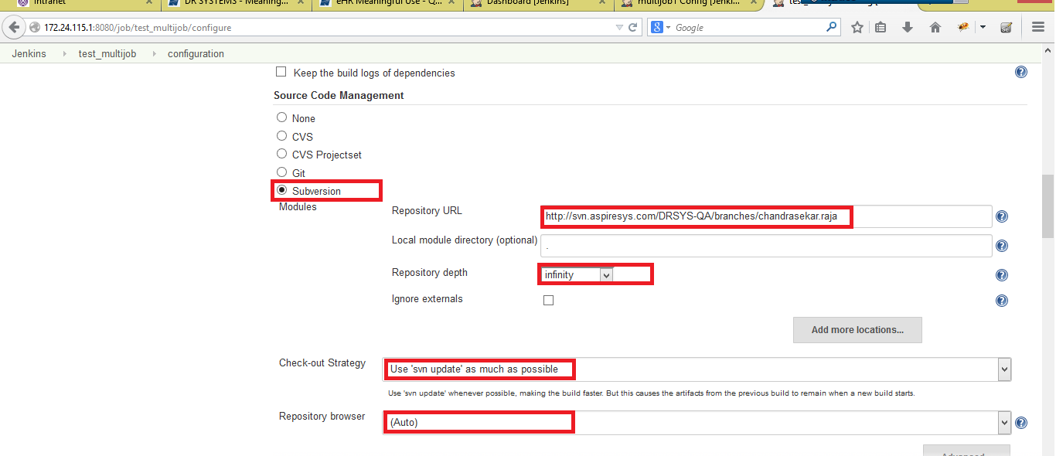

**Note :** The **repository url** should be **set** only for the **Multijob** and not for the jobs added under multijob (only **None** should be set to these jobs)

* 1. Click **Add build step** button and select **Multijob Phase** and then add the required jobs

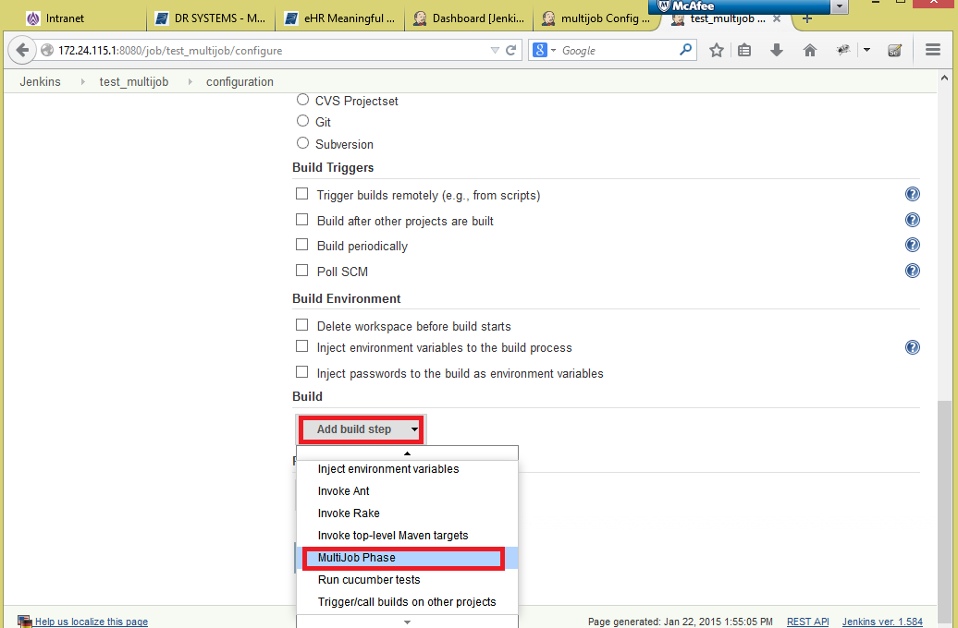

* 1. Add job details by entering **phase name**, **job name,** select **‘Never (ignore the job result and continue the phase execution)’** option for kill the phase on option and **uncheck** all the **checkboxes**

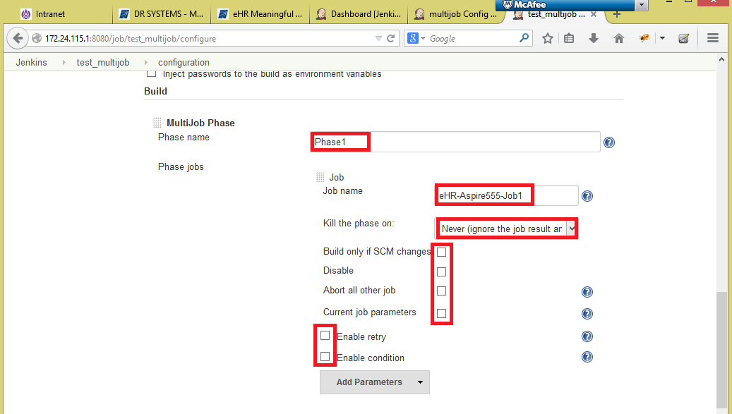

**Note :** A Phase can have multiple jobs and all jobs in a phase will be executed in parallel and all phases will be executed in sequential manner

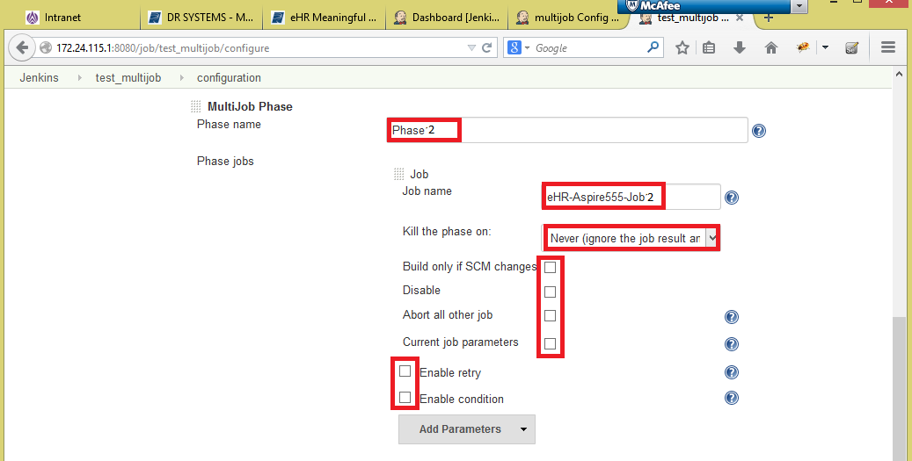

**Configuration for jobs under multijob :**

1. Create a normal **(Free style project**) job with **job name**, **execution machine (node name)** and under **Source Code Management** select **None** radio button (as only the Multijob can have the repository url) and under **Build** click **Add build step** button and select **‘Execute Windows batch command’** and give the repository location of Multijob created

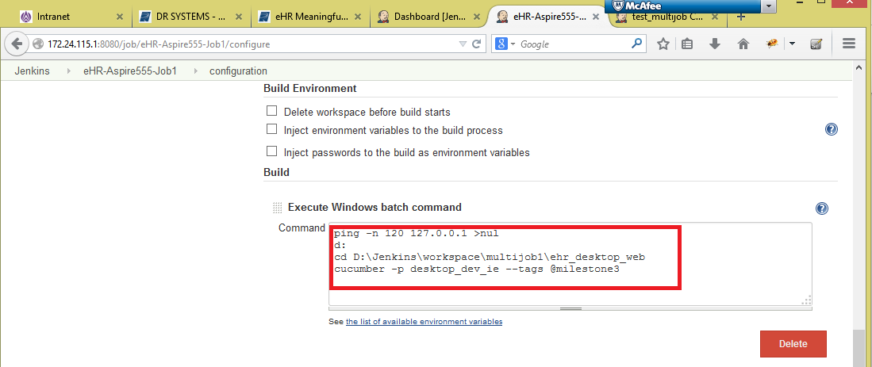

1. Click **Add post-build action** button and select **‘Publish cucumber results as report’** option

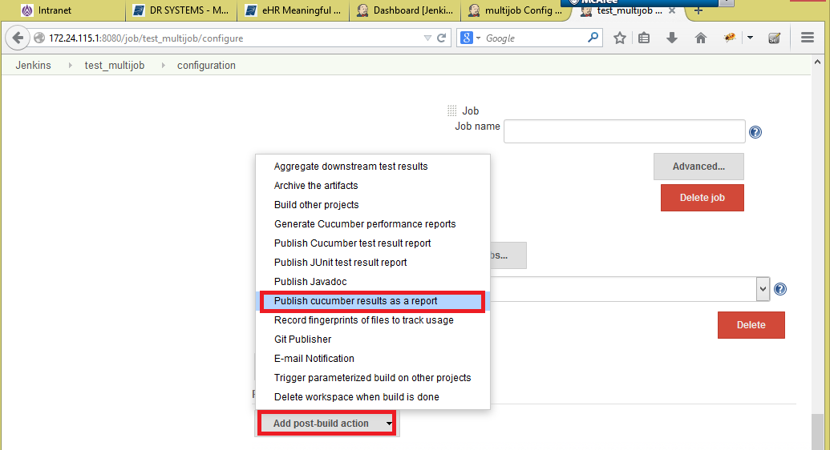

1. Click the **Advanced…** button and enter the test result location of multijob repository in **the Json report path** field

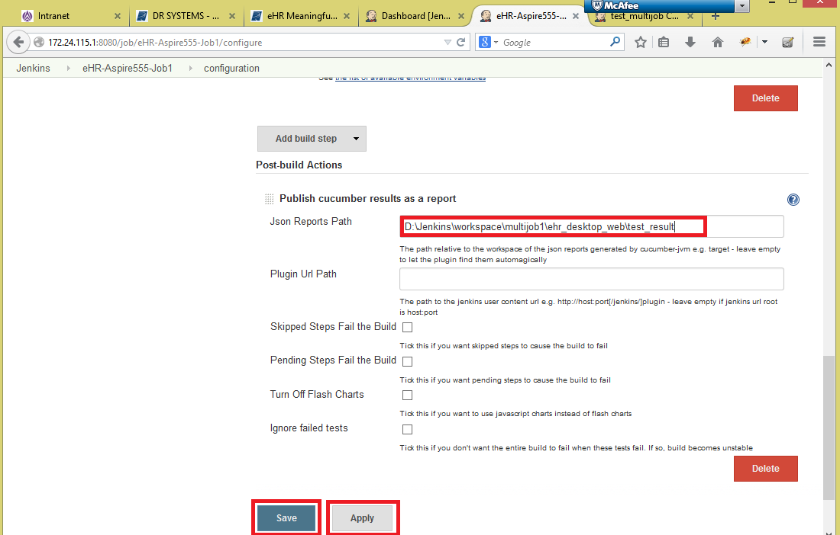

1. Then click **Save** and **Apply** buttons